MA 323 (2020) Monte Carlo Simulation Lab 09

**Name:** Udandarao Sai Sandeep

**Roll Number:** 180123063

**Dept.:** Mathematics and Computing

**Note:** Both the questions have been coded in a single file.

**Q1.**

**Starting Stock Price** was set to 185.40 (Stock Price as of 30th September 2020)

**Strike Price** = K = 1.1 * 185.40

The values of **mean** and **variance** from Lab Assignment 7 were used.

**µ** = 0.0002981060700200034

**σ2** = 0.000496475360718651

**Box Muller Method** was employed to generate values from the **Normal** **Distribution**.

**Time** **Interval** was set to **0.1**. (30 Days, 300 Time Points)

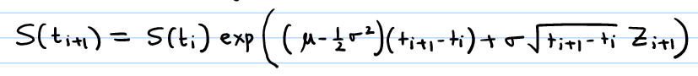The following simulating formula was used to simulate the stock prices. (GBM Model)

The **Average Price Asian Put Option Payoff** was calculated. (using the formula given in the Assignment)

The process was repeated **1000** times.

The Generated Asian Put Option Payoffs were stored in **array** **Y**.

The **mean**, **variance**, the **standard** **variation** and the **95% confidence interval** of the generated Asian Put Option Payoffs was then calculated using NumPy module of Python.

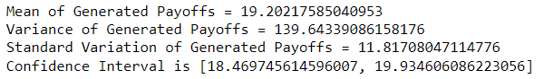

**Q2.**

Along with the Average Price Asian Put Option Payoff, **European Put Option Payoff** was also calculated. The European Put Option Payoffs were stored in **array** **X** (which would act as the **control** **variable**).

Now, using the below formula, the value of b was estimated.

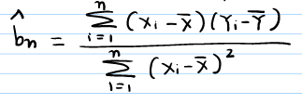

Using Arrays X, Y and b, the values of the **controlled** **variable** were calculated as follows:

 (for ith replication)

Using the NumPy module of Python, **mean** and **variance** of the **controlled** **variable** was found. They are as follows:

As expected, the mean of the Controlled Variable is equal to the mean of the Original Variable.

There is a significant decrement in variance (from 139.643 to 39.691).

Results summed up in Tabulated form:

|  |  |  |  |
| --- | --- | --- | --- |
| Variable | Mean | Variance | Confidence Interval |
| Asian Put Option Payoffs | 19.202175 | 139.643390 | [18.46974,19.93460] |
| Controlled Variable | 19.202175 | 39.691725 | [18.81168,19.59266] |